UNIFIBER
Commercial
B2B

Annex 3B
Working Level Agreement
21 November 2022

Table of Contents

1. Table of Contents 2
2. General Provisions 3
3. Delivery process – Ordering & Provisioning 3
Ordering & delivery of a dedicated point-to-point Dark Fiber pair 3
OTDR and Ready for Service notification 4
Information exchange 4
Interface 4
Address Check 4
Address U 4
Order types 4
4. Forecasting Procedure 5
5. Ancillary Services 7
6. Financial Process 7
7. Appendix 1: More information on the POP Location Services 8
Layout Central & Area POP 8
Power and climate 9
POP facility details: 9
Cooling 10
Access request third parties 10
POP location roles & responsibilities 11
8. Appendix 2: Forecasting Template for Wholesale ODF Access 12
9. Appendix X: For in Standard Annex 3? 14
Ethernet Solution 14
PON Solution 14
Direct Point-to-Point Connection 15

General Provisions

This Working Level Agreement (WLA) for Wholesale Business Access is designed to create a common understanding about all working procedures, including responsibilities between Unifiber and Operator, concerning the delivery of those services (WLA).
This WLA will be updated or adjusted according to operational needs.
Parties agree that this version of Annex 3B (WLA) is a draft version and that the document will be completed and finalized within three (3) months from signature date of the Agreement.

Delivery process – Ordering & Provisioning

Ordering & delivery of a dedicated point-to-point Dark Fiber pair

The technical scope of a dedicated point-to-point Dark Fiber order can vary much: i.e. depending on soil, length of private terrain to cross, technical possibility to realize the local tail (making use of existing available duct or need to trench for dedicated new duct) – ultimately resulting in varying timelines and cost levels.
An order request will first result in a theoretical design and budget estimation – based on which Unifiber will provide Operator with a quote.
Order process and delivery date
As soon as Unifiber receives a signed order, Unifiber (or its contractor as the case may be) will at first schedule a site survey, exactly determining the technical scope of the local tail at end-Business Customer Premise. Based on the site survey and potentially accepted (significant) cost deviations, the order is provided with an expected Delivery Date. Depending on the network realization scope, permits are requested and work scope prepared. As soon as permits are received, the expected delivery date will be altered to a more reliable Committed Delivery Date. The civil works are performed, building entry created and the ODF placed. To confirm the quality of the fiber path, an OTDR measurement takes place.
The realization of the local tail allows for a dedicated fiber pair to enter the building and both fibers will be terminated at an ODF. The fiber pair will be spliced on the existing Network to create the dedicated fiber route to the selected POP location. At the POP location the fiber pair will be terminated at a Unifiber ODF, allowing for patching to Operator Equipment.
In parallel, Unifiber shall grant Operator access to the selected POP location to allow for the necessary patching activities. An Access protocol will be in place.
Both parties (Unifiber and Operator) need to cover the necessary details and information for individual orders to be realized in the shortest as possible timeframe. It is Operator responsibility to provide in accurate end-Business Customer data and manage expectations on the realization process to come – allowing a most efficient process and resulting in shortest lead times, highest percentage of first time right and a process that is as much customer oriented as possible. Unifiber and Operator will constantly seek to improve the process.

OTDR and Ready for Service notification

As a standard, a bi-directional OTDR measurement at a standard wavelength of 1550 nm is performed. Unifiber can perform this OTDR measurement at wavelengths of 1310 and/or 1625 nm upon request if desired. As a confirmation of the delivery, Operator receives a ready-for-service (RFS) Notification which lists the line identifiers and location details (including an OTDR report).

Information exchange
Unifiber and Operator will exchange the following information per order:
- Order confirmation
- Expected delivery date
- Adjusted delivery date
- Confirmation of delivery

Interface
API or Web Interface

Address Check
Qfsq

Address U

A Wholesale Partner Business Operator can request Unifiber to add along an already deployed Homes Passed network, a newly defined Business Business Access Point (e.g. street cabinet, manhole, mini-POP, etc). As far as spare capacity is left in the Access Fiber, Unifiber will connect the Business Access Point as a standard Business Business Access Point. To allow system connection to that Business Business Access Point, an additional Address U will be created first. From that point onwards, existing business connection processes will be followed.

Order types

Unifiber distinguishes 4 order types that are available for Wholesale Business Access.
The first two order types are related to the installation or the cease of the Business Business Access Point.
- Activation Order: This order will assure there is an end-to-end connection between the Business site and the Business Operator Backhaul. It will cover the physical installation of the drop cable including an FTU or ODF (option) at the premises and all necessary patches at the designated Area POP. One fiber or two fibers (option) can be delivered and will be ready for activation by the Operator.
- De-activation Order: in the event Operator decides to no longer make use of the fiber connection for its services, a de-activation order is sent in to de-activate the fiber connection to the Business Access Point. Unifiber will de-patch at the Area POP.
Additionally, the following 2 order types will be required to deliver active services from the Area POP where a splitter or ethernet switch is installed to the Central POP where active equipment is installed.
- Feeder Capacity Order: a single or double fiber (option) and optionally a splitter of 1:32 is installed between the Area POP and the Central POP. This order needs to be pre-ordered to be able to orde the above-mentioned orders 1 – 2, as these are terminated at a splitter or ethernet switch in the Area POP. Also P2P dark fiber-pair can be ordered as an optional service.

- Rack Space Order: standard available rack space capacity is 1/2 or 1 rack, in addition to power consumption as further described in section X. Operator may select to install its Operator Equipment in both Area and Central POP.

Forecasting Procedure

The forecasted volumes are established by a dedicated person within Operator and communicated, when possible, per type of intervention for Wholesale ODF Access products (Wholesale ODF Access or Patch Orders).

The forecasts are prerequisites for the respect by Company of the SLA on slot availability for orders submitted. Forecasts are needed to help Company plan a reasonable capacity to fulfil Operators’ demands. Slot availability will be offered in such a timeframe that it offers on one hand a long enough period for the Business Customer to have several options and on the other hand in such a timeframe that the filling up of slots results in a tight as possible scheduling to allow for optimal use of contractor capacity.

Operator is guaranteed that the Company will set-up the necessary resources for the period concerned to meet its market needs, based on the hereafter mentioned forecasting procedure.

For the three first series of forecasts, both Parties will enter into good faith discussions about the submitted forecasts and the feasibility to implement the forecasts concerned. A forecast is made up out of 2 components:

- Expected number of orders in the first wave period*, necessary for capacity alignment with the homes connect deployment contractor
- Expected number of orders in the ‘catch up’ or exploitation phase, necessary for capacity alignment on a regional level. When Parties agree the first wave period comes to an end, the forecasted number of orders of that Deployment Area will be added to the regional overview.

* The so called first wave is the first period of Homes Connect installations which is expected to follow closely after the Initial Delivery of each Fiberzone. This is the period in which there is an expected high uptake percentage as a result of Operators’ marketing & sales activities. After a certain period in time, the first peak of interest and orders will come in more gradually, resulting in smaller numbers of orders. The duration of the first wave period will be determined together with the subcontractor and Operator(s) active in the relevant Deployment Area, based on type of area (dense or more rural), forecast of Homes Connect numbers (potentially based on demographic figures that Operator has, known base of Business Customers for migration, etc.) and other relevant factors.

The Operator is responsible for the accuracy of the forecast. Therefore, Operator is requested to submit monthly its forecast for the next 6 months, at the latest by the first day of each month. Forecast modifications or confirmation shall be done through the use of the templates provided by the Company (see Appendix 2). These templates will only be considered as valid when they are properly completed. In case data is missing or is not correct, the forecast will be rejected (within 2 working days following its reception). In the latter case, the reasons of rejection will be indicated on the template by Company. After rejection, Operator has 2 working days to rework its forecast accordingly. If no modification is received by that time, the Company will consider as forecast the mathematical average of the actual ordered volumes of the Operator over the last 6 months.

For each forecasted month common to 2 successive forecasts, the maximum deviation between the successive forecasts of this month at month M and at month M-1 will be – 30% to + 30%.

Deviations between forecasted volumes and actual volumes
- Underrun: Underrun occurs when actual ordered volumes are below forecasted volumes. A reasonable underrun of the forecasted volumes can be absorbed by Company and has no direct consequences for the Operator. A reasonable underrun is considered to be no more than a 15% deviation of the forecasted volume, considered on a monthly basis. In case of multiple repetitive and severe underruns (e.g. 3 consecutive months), Company reserves its right to define on behalf of Operator to a level deemed necessary by Company a reasonable forecast for the months to come (based on the mathematical average of the actual ordered volumes of the Operator over the last 6 months).

- Overrun: Monthly Overrun occurs when actual ordered volumes have a deviation superior to 15% above forecasted volumes.
As from the first order exceeding this deviation, all orders of the Operator for the remainder of the month will be considered in “overrun”, meaning that conditions of the slot availability within the SLA will be fulfilled on a best effort basis.
The following milestones are shared between both parties:
- Start civil works
- Initial Delivery by the company of # Homes Passed network per Area POP (Fiberzone)*

* When the availability check provides a positive outcome on available network it means that agreements with relevant syndics are in place and distribution network (Homes Passed network) is available to provide Homes Connect realization in the building.

For forecasting & capacity purposes, the following numbers are measured and exchanged between parties:
- # Wholesale ODF Access order intake
- # Wholesale ODF Access orders connected
- # Patch orders
- # Patch orders delivered
- # Termination orders
- Lead times per order type

Ancillary Services
The ancillary services that may be provided by Unifiber are the following, and shall be charged separately to Operator:
- Useless interventions
- Order Rescheduled <24h upon Operator’s/Customer’s request
- Cancellation during roll-out
- Connection quote

Financial Process
For invoicing of each activated fiber, Operator will provide Unifiber with an order per individual installation address.
The following mandatory invoicing requirements are applicable for all transactions:
- Date of issue of the invoice;
- VAT identification number Vendor;
- VAT identification number Business Customer/purchaser;
- Full name and address of the Vendor;
- Full name and address of Business Customer;
- PO number that is provided by Operator
- Description of service type
- The unit price exclusive of tax;
- Taxable amount per VAT rate. Each invoice will present a total amount excluding VAT, total amount of VAT and the total amount including VAT;
- The total VAT amount payable (must be expressed in the currency of the country where the transaction takes place, expressed in an exchange rate if you want to mention another currency; all Unifiber invoicing takes place in Euro);
- Reference on the invoice in specific cases;
- Details tax representative, the following details should be mentioned on the invoice in case the person liable to pay the VAST is the tax representative:
  - VAT identification number
  - Full name and address

Unifiber will invoice recurring charges monthly in advance (in the beginning of each running month). Unifiber will invoice one-off charges as an addition to the monthly invoice, on the moment when Unifiber incurs the costs or provides the service.
In the unlikely event Operator notices that the invoice is made up with incorrect data, Operator contacts Unifiber within 30 days after receipt of the invoice. Unifiber will, when incorrect data is confirmed, adjust the invoice. Operator commits to pay the non-disputed part of the invoice within the agreed payment terms of the Agreement.
In the event the incorrect data is discovered after payment of the invoice, parties shall enter into mutual consultation. The correction of the payable amount is possible up to 12 months after the final payment date of the amendable invoice.

Appendix 1: More information on the POP Location Services

Layout Central & Area POP
Unifiber has selected one (1) standard POP type for both Central and Area POP. Besides new build POP locations, Unifiber also makes use of existing POP locations or granted building space in which we aim to create an as much as standard layout as described below.
The outline of the POP location is displayed below:
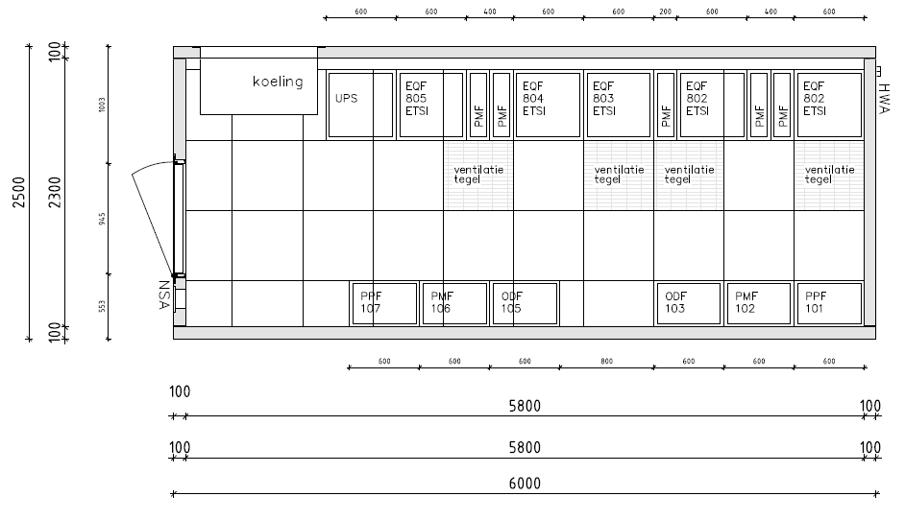

Definitions:
Cooling: Space reserved for the cooling unit for climate control
UPS: Uninterruptible Power Supply (also DC system) for autonomy in case of power failure
ETSI: Standardized dimensions of depth and height units
EQF: Equipment Frame in which active equipment is installed
PMF: Patch Management Frame for controlled routing of patch cords
NSA: “Nood Stroom Aansluiting” meaning Emergency Power Connection for the external connection of an emergency power generator in the event of a long power outage
ODF/PPF: Optical Distribution Frame where passive components such as patch / splicing units are installed
The Central & Area POP location(s) allow housing of Operator equipment which can be placed in requested rack space. Key features include:
Access and monitoring specifications of Unifiber POP Locations
Available facilities and alarms connected to a controller that is directly linked to the NMC
Feature | Required | Additional remark
Controller in combination with CPE | X
Electronic Access provision | x
Access via key | X
Burgleralarm | X | Forced entry
Net watcher sensor (power supplier) | X
Temperature sensors | X
Smoke detectors | X
Leak detection | X
UPS/batteries/rectifier (DC) | X | Autonomy >45 min
UPS failure sensor | X | 1x power supply eg down
NSA connection | x
Camera surveillance | x
Climate control (free cooling) | x
Emergency lighting | x

All systems comply with all legal requirements and industry standards and are regularly inspected and maintained according to the applicable standards.

Power and climate
Details of the electrical installation:
  - Power to be requested from the supplier is 15Kw
  - The total power of the POP is set at a minimum of 12kW
  - Voltage type per EQF DC voltage (DC)
  - 2 kW is available per EQF
  - With shared use of the EQF, it is issued per 23 HE (half EQF) with a maximum power of 1000 watts
  - The 2 kW UPS with 1 battery string is intended for 120 minutes of autonomy support of the facility systems
  - DC autonomy for Operator equipment is set up to cover 120 minutes. Longer autonomy in case of power outage to be realised by bringing a mobile generator unit on site. The maximum power available shall be 800 W DC/20HE.

POP facility details:
- Unifiber will make available to the Operators ETSI racks allowing installation of ETS 300119-4 sub racks. Unifiber will provide rack space per 23HE (half rack) as a standard to enable Operator to install equipment and connect it to the Unifiber ODF.
- The racks are installed in a room that guarantees environmental conditions according to ETSI ETS 300019 class 3.1
- The racks shall be flexible regarding the airflow through the equipment (bottom to top; left <-> right; back <-> front).
- The Operator has the option to install equipment with 48V DC ETS300132-2 power supply.
- The POP shall be designed to respect local environmental guidelines. The facility equipment (telecom equipment excluded) including cooling unit will comply with ETSI EN 300 753. Regional regulations specifying the maximum sound pressure at limit of the local and Central POP property will be respected. Unifiber will ensure that total noise at a site is compliant with regulation and will align with Operators accordingly. Please find acoustic simulation cool unit at Annex 1.
- Between the racks and the ODF, a fiber guidance system (gutters and cable racks) shall be installed compatible with bending radius of fibres G.657.A1 and G657.A2. In the rack, equipment with cabling leaving the card horizontally to the side or vertically to the top of the equipment will be supported. A suitable cable guidance system from the equipment to the top or the bottom of the rack (depending if the cable routing is designed through overhead cable gutters or by using a false floor) will be present (PMF, Patch Management Frame).
- Airflow regulation within the rack space is Operator responsibility.

Additional remarks regarding the shared use of the EQF:

- The PDU (Power Distribution Unit): sub rack into telecom rack that can house modular automatic fuses is provided by Unifiber, as well as the cabling between it and the rectifiers. It provides DC A and DC B powering. The modular automatic fuses can either be provided by the Operator or Unifiber, as well as the cabling PDU-telecom equipment. However a fuse panel in a rack (or ¼ a rack) will cost rack space. It is preferred that a fuse panel will be installed into their rack in order to avoid Operator coming into the distribution board. If Unifiber provides the fuse panel in Operator rack there will be uniformity and risks of human failure will be minimalized. The automatic fuses are clipped on a 35 mm DIN rail and 18 mm width. Unifiber will align with Operator on this installation specification.
- In order to hold the 48V voltage at end of battery discharge to power feed the telecom equipment within the ETSI ETS 300132-2 limit, the section of the powering cables (as well DC as return) will be dimensioned taking into account the maximum cable loss PDU-Operator Equipment of 1V (DC and return).
The battery autonomy will cover the time to bring and connect an external power generator. The contract to rent and connect the power generator is under the responsibility of Unifiber.
- The RGIE/AREI is applicable to the installation.

Cooling
A VKU (Free Cooling Unit) type 4000 has been chosen. This means that the cooling is regulated with “outside temperature”. The temperature in the POP is therefore dependent on the outside temperature and is in line with the operating specifications of common telecommunications equipment used in Fiber to the Home networks. Below table shows the expected temperatures in relation to the outside temperature. This cooling method is very low in energy consumption and is therefore switched behind the UPS. It is maintenance-free and has a very long service life of > 15 years.
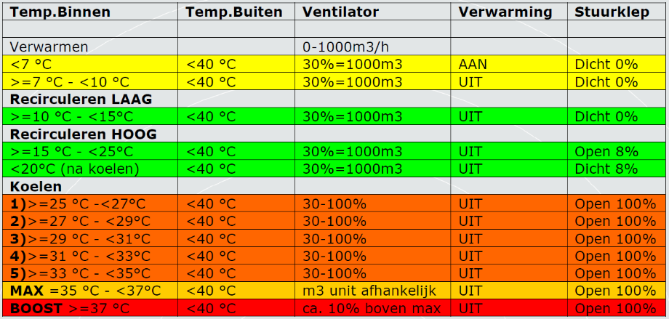

Access request third parties

Access request by Operator for third parties will only be processed if the requestor is authorized to submit the request. Authorization levels by person according to “contact and authorization list”. This request must be submitted 24 hours in advance and must contain the following information.
- Visitor name
- Visitor Phone number
- Date of visit
- Time of arrival
- Estimated duration
- Reason for visit

POP location roles & responsibilities
Operator equipment installed in a POP location remains the property of the Operator and can be maintained and removed by Operator in accordance with the access regulations that will be defined by Unifiber. Operator shall ensure that the equipment installed meets the requirements set out in chapter 1.3.1 and complies with the interfaces specifications.
Upon expiration or termination of the POP service, and unless Unifiber and Operator have agreed otherwise in writing in advance, Operator shall:
- Remove its equipment at the POP Location
- Hand over its access means to the POP (e.g. key or Access pass) to Unifiber
within 30 days of the expiration or termination of the POP service.
Operator will not cause any nuisance or inconvenience to other users in the POP Location in which the Operator Equipment is installed.
Unifiber is responsible for the application for and possession of any compulsory government permits, consents and/or exemptions for the use and operation of the POP’s. The associated costs will be borne entirely by Unifiber. At the request of Unifiber, Operator will provide all cooperation necessary to apply for and keep the permits, consents and/or exemptions.
The following ETSI standards are applicable to Operator Equipment and Unifiber environment:
- Mechanical : ETS 300119-4
- DC Powering : ETS300132-2
- Environmental : ETS 300019 class 3.1
- Emitted sound power : ETSI EN 300 753

Appendix 2: Forecasting Template for Wholesale ODF Access

Forecasting Template for Wholesale ODF Access & Patch Orders
Operator Reference:
Edition:
Split: Select Type of Orders (Wholesale ODF Access or Patch Orders)
Issue Date:
Zone |  | M₁ | M₂ | M₃ | M₄ | M₅ | M₆
Deployment Area 1
Deployment Area 2
…
….

Checklist
Ancillary Services
Roll-Out Process
Equipment in POP
Passive Network Technical Equipment
Ordering & Provisioning
Processes for Governance & Operational Aspects
Maintenance of Services
Business Access Point Portability

Appendix X: For in Standard Annex 3?

Operator can use any of the three following connectivity solutions between the Area and Central POP:
- Ethernet
- PON (Passive Optical Network) or
- Direct Point-to-Point
Those 3 options are explained in more detail below.

Ethernet Solution
In this case, Operator places active Ethernet equipment in its rack in the Area POP (requiring additional DC power to the basic rack provisions). Each individual Wholesale Business ODF Access connection will be terminated to the Ethernet switch.
Operator either provides for backhaul connectivity at the Area POP themselves or orders a POP- or feeder ring connection to the Central POP and assures backhauling via the Central POP. The Ethernet connectivity to the Central POP can be provided on 1 or 2 fibers via a ring or in P2P e.g. Juniper MX204 Edge Router in Central POP and ACX710 Metro Router in Area POP

Drawing to be included.

PON Solution
In this case, all individual Wholesale Business ODF Access lines are terminated via a patch on a by Unifiber provided splitter in Operators’ (a central Unifiber rack????) rack in the Area POP and Unifiber provides a single fiber POP- or feeder ring connection to the Central POP.
Unifiber provides standard in a 1:32 splitter and a dedicated Point-to-Point single dark fiber connection from the Area POP to the Central POP over the POP-ring. However, splitter ratios can be adjusted by Operator according to Operators’ specific network design and dimensioning strategy. Splitter ratios of 1:16 and 1:8 are also possible. Unifiber will comply and dimension the feeder capacity accordingly, either by adjusting the splitter in use (and ordering additional feeder capacity) or ordering new feeder capacity with a new (other dimensioned) splitter.

Drawing to be included.

PON equipment can also be installed directly in the Area POP. In this case, it runs further to the Central POP via an (optional) direct Point-to-Point fiber pair over the POP- ring, and from the Central POP, where backhaul is arranged by Operator.

Drawing to be included.

A third option is do backhaul directly to the Area POP where a patch from the incoming ODF is placed to the Operator Equipment. Also in this case, the splitter is provided by Unifiber.

Drawing to be included.

Direct Point-to-Point Connection
In this case, the individual Wholesale Business ODF Access line (2 fibers) in the Area POP is patched through to the Central POP (on the event only via the manholes in front of the Central POP) using a dedicated fiber pair on the POP- or feeder ring.

